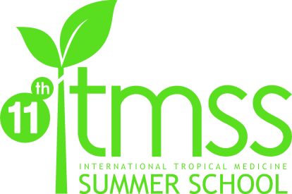

Passport SizeD Recent Photograph

International Tropical Medicine Summer School
Muhammadiyah Medical Students’ Activities
Faculty of Medicine and Health Science
University of Muhammadiyah Yogyakarta
DIY - Indonesia
P: 62 274 387 656 ext. 213, F: 62 274 387 658
E: itmss.indonesia@gmail.com, W: itmss.umy.ac.id

STUDENT APPLICATION FORM ITMSS 2015
This year ITMSS will be running from 10th– 27th August 2015.
Applications close Saturday, March 24th 2015
All students seeking to apply for ITMSS 2015 must complete this form in its entirety.

PERSONAL DETAILS

Last Name: |  |  |  | First Name:
Date of birth: |  |  |  | Sex: [ ] Male [ ] Female
Address:
Preferred Communication: [ ] Phone [ ] Email |  |  |  | Nationality:
Home Number: |  |  |  | Mobile Number:
Email Address: |  |  |  | Instant Messenger:
University:
School Attended: [ ] Medical |  |  |  | Native Language/s:  Other Language/s:
Level: [ ] Student* [ ] Graduate
*Year Level in 2015: |  |  |  | Passport Number:
 | [ ] Pre Clinic [ ] Clinic |  |  | Passport Expiration Date:

EMERGENCY CONTACT DETAILS

Last Name: |  |  | First Name:
Relationship: |  |  | Contact Number:

MEDICAL INFORMATION
Date of last tetanus immunization:
Is there any other immunization you have taken? [ ] Yes – please specify [ ] No
Do you have any medical conditions? [ ] Yes [ ] No - If so, please provide details:
Do you have any allergies? [ ] Yes [ ] No - If so, please provide details:

Will you be taking medication during Summer School? [ ] Yes – please specify [ ] No
Student Medicare: |  |  |  | Health Insurance:
Do you have any special dietary restrictions including for medical, religious or personal reasons? (E.g. vegetarian, halal food) [ ] Yes – please specify [ ] No

OPTIONAL CLASS
We will hold 3 (three) Optional Class in ITMSS 2015. Please choose according to your priority.
[1] Music Class
[2] Bela Diri (Indonesian Martial Arts) Class
[3] Dancing Class

Example : 3,2,1 Your choice : ________________________________

HOSTING
For the participant who has a friend from the same country, you can choose to live in a close area. Please mention us whom you want to be placed closer with.
Your friend’s name:

SOCIAL PROGRAM
We provide you social programs which you can visit some incredible tourism and cultural objects around Yogyakarta-Indonesia together along with other participants. This social program fee is not included in registration fee. It costs 140 EUR. If you want to join this social program, you have to pay and transfer it with the registration fee : 545 EUR in total.
Do you want to join this social programme? [ ] Yes [ ] No

LOCAL GSM NUMBER
Will you bring your mobile phone* during the program? [ ] Yes [ ] No
If so, would you like to use local GSM number while staying in Indonesia? [ ] Yes [ ] No
We will provide a local GSM number to each of ITMSS students. This way is intended to conduct an easier communication between students, the organizing committee members, and home stay parents. We will also put in our consideration about the most competitive international call tariff before we choose which provider to use.

*Indonesia GSM networks range is available to use in only GSM900/1800 and 3G network. Please check your tri-band feature, while quad-band would not have any problem to run in any countries.
T-SHIRT DETAILS
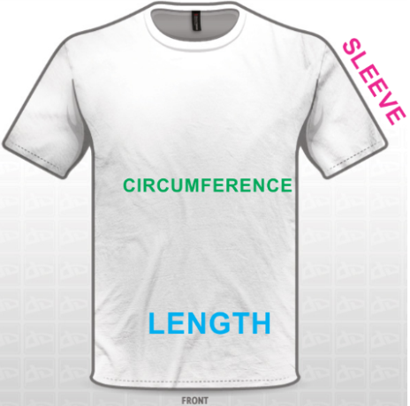
T-Shirt size: [ ] XS [ ] S [ ] M [ ] L [ ] XL [ ] XXL
SIZE | LENGTH | WAIST CIRCUMFERENCE | SLEEVE
S | 66 cm | 90 cm | 18 cm
M | 69 cm | 96 cm | 96 cm
L | 72 cm | 102 cm | 22 cm
XL | 75 cm | 108 cm | 24 cm
XXL | 77 cm | 118 cm | 25 cm
XXXL | 80 cm | 124 cm | 27 cm

SUMMER SCHOOL EXPERIENCE
Is there any medical summer school you have attended before? [ ] Yes – please specify [ ] No
Name | Topic | Year | City & Country

ITMSS 2015 SURVEY
How do you rate your knowledge in the field of tropical medicine?
[ ] None, but I’m eager to know [ ] Beginner* [ ] Experienced in this field*
*If you check one of the boxes with this (*) sign, please state briefly why you rate yourself in that level.

How did you hear about ITMSS 2015 ? (You can sign more than one checkbox)

[ ] Friend/previous ITMSS student
[ ] Email
[ ] Faculty
[ ] Poster

[ ] Leaflet
[ ] Website (including Google search)
[ ] Publication in Medical Conference

[ ] Mailing list, please specify

[ ] Others, please specify

MOTIVATION AND EXPECTED OUTCOMES
Motivation letter:

In order to raise our students’ satisfaction, we will very please if you could state briefly your expected outcomes by joining ITMSS 2015.

PAYMENT
- Cost
- 405 EUR
- This payment includes: Accommodation (home stay), transportation (arrival from airport to home stay, home stay to venue, any transportation needed during arranged educational and non educational programs, and departure from home stay to airport), one cultural program, and two times meal for the duration of the Summer School.
- This payment does not include: Tour and social programs activities to tourism objects, banking transfer, health insurance, visa and travel expenses.
- 545 EUR
    - This payment includes: Tour and social programs to tourism objects, accomodation (home stay), transportation (arrival from airport to home stay, home stay to venue, any transportation needed during arranged educational and non-educational programs, and departure from home stay to airport), one cultural program, and two times meal for the duration of the Summer School.
    - This payment does not include: Banking transfer, health insurance, visa and travel expenses.
- Additional accommodation
Students will receive free accommodation during period of arrival on two days before the program starts, and departure until two days after the program ends. Please indicate to Liaison Officer if any extra nights of accommodation are required. (Students will be charged an extra EUR 6 per night).Please note that additional accommodation covers accommodation only. Students are responsible for paying for their own food and transportation during the free/charged extra nights. Travel itinerary should be confirmed to the Liaison Officer one week before arrival or departure.
- Payments that have been made are not refundable.
- Before the ITMSS 2015 starts, changes to the Terms and Conditions are possible to be made by the Organizing Committee without any permission from the students.
If there are any changes have been decided, the Liaison Officer will inform all students immediately.

METHOD OF PAYMENT
- Bank Transfer
We will start the payment period from March 25th – April 3th, 2015. The official bank account will be announced soon to the applicants via email.
If you have any problem with this method of payment, feel free to contact us.

(Place) , (date) 2015

Signature here

- Please print this form after you fill in its entirety, and sign it with written signature.
- Send a color scanned document of this form to: itmss.indonesia@gmail.com, and bring the original form when you join this program.

